605 DOME LIGHTS AND TAXI NUMBERING SYSTEM

605.1 No later than April 30, 2013, all licensed taxicabs in the District of Columbia shall be equipped with the Commission-approved Dome Lights and Taxi Number System that meets the specifications listed below and any further specifications provided by the Commission:

- The Dome Light shall display the public vehicle identification number (“PVIN”) assigned by the Commission on the left side of the Dome Light when viewed from the front and the right side of the Dome Light when viewed from the rear of the dome light;

- The Dome Light shall be connected to the engine and that portion of the Dome Light that displays the PVIN shall remain on at all times when the car’s engine in on; provided, however, that the Dome Light may contain a driver activated switch located on the side of the Dome Light that will allow the complete Dome Light to remain dark when the vehicle is either off-duty or is being utilized for personal use;

- Roof Light Housing shall be aluminum or silver colored acrylic

- The left part of the Dome Light shall be silver in color with the PVIN etched in white plastic acrylic letters and housing a bulb to illuminate the PVIN, with further specifications to be provided by the Commission;

- The right portion of the Dome Light shall be silver in color with a clear acrylic cover that shall contain a single line LED programmable moving display that scrolls “TAXI FOR HIRE”;

- The base shall be constructed of aluminum with a continuous neoprene base that surrounds the entire base with several rubber gaskets to allow for drainage of water and condensation.

(g) A visual depiction of the dome light is shown below:

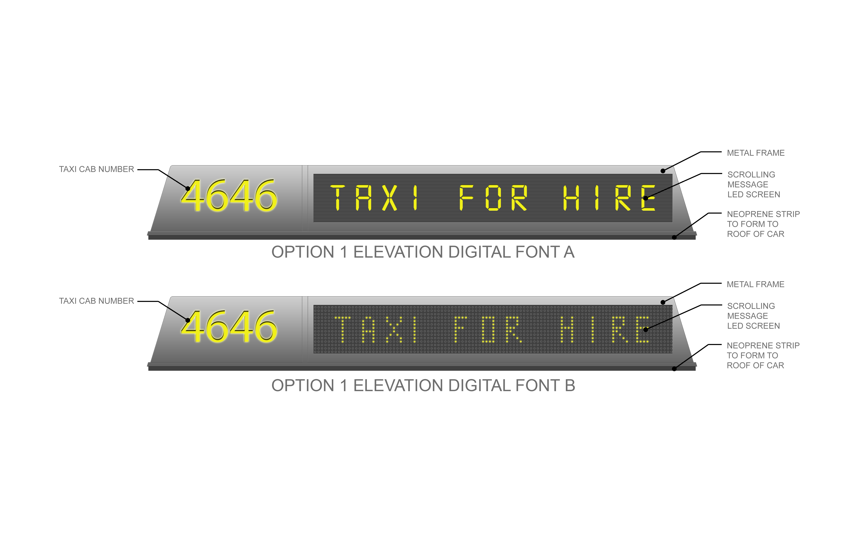

605.2 The required dome light shall only be installed by Dome Light Installation businesses authorized by the Commission to install the approved dome light pursuant to Chapter 15 of this title.

605.3 The Dome Light shall be fully visible to a person of average height at all times when the vehicle is cruising. Vehicles of greater length or height shall be required to have two (2) fully functioning dome lights. Vehicles that contain advertising signs on the roof shall have a fully functioning dome light on the front and rear of the advertising sign.

605.3 Each new Dome Light will identify the newly assigned taxicab vehicle identification number assigned by the Commission to that specific taxicab vehicle.

605.4 The PVIN does not replace a taxicab company’s, association’s, or fleet’s taxicab fleet numbering system provided in § 503.10 of this title. However, the PVIN on the Dome Light will replace the current vehicle identification numbers assigned to independently operated taxicabs pursuant to § 505.7 of this title.

605.5 The LED portion of the Dome Light shall display “Taxi For Hire” at all times when the taxicab is available for hire and the LED portion of the Dome Light shall go “dark” when the taxicab is not available for hire because the taxicab is carrying a passenger, is on call, or is off duty not intending to take on passengers. The Dome Light may contain a driver activated switch on the side of the Dome Light that will allow the complete Dome Light to remain dark when the vehicle is either off-duty or is being utilized for personal use.

605.6 Whenever a taxicab operator removes his or her vehicle from service and is proceeding to a place of his or her choosing without intending to take on passengers, the “Taxi For Hire” light shall go “dark.”

605.7 Whenever a taxicab is responding to a dispatch call or proceeding to a prior arranged transport, the “Taxi For Hire” light shall go “dark.”

605.8 No taxicab shall be operated unless its Dome Light is in proper working condition. The operation of a taxicab with a broken Dome Light shall give rise to a rebuttable presumption that the driver knew of the condition and operated the taxicab with such knowledge.

SOURCE: Final Rulemaking published at 37 DCR 3595, 3605 (June 1, 1990); as amended by § 3 of the Taxicab Commercial Advertising Amendment Act of 1992, D.C. Law 9-218, 40 DCR 556, 557 (January 22, 1993); by Final Rulemaking published at 45 DCR 8866, 8867 (December 11, 1998); as amended by Final Rulemaking published at 59 DCR 8564, 8570 (July 20, 2012); as amended by Final Rulemaking published at 60 DCR 1173 (February 1, 2013).

